FIELD MAP
CLUBHOUSE
Team Tent Area
TEAMS CAN WARM-UP HERE (JUST FIND AN OPEN SPACE)
PARKING LOT
River Soccer Club (32221 Gum Rd, Frankford, DE 19945)
Fields Closed – Do Not Enter
Field
2B

Field 2
Field
2D
Field
2A
Field
2C
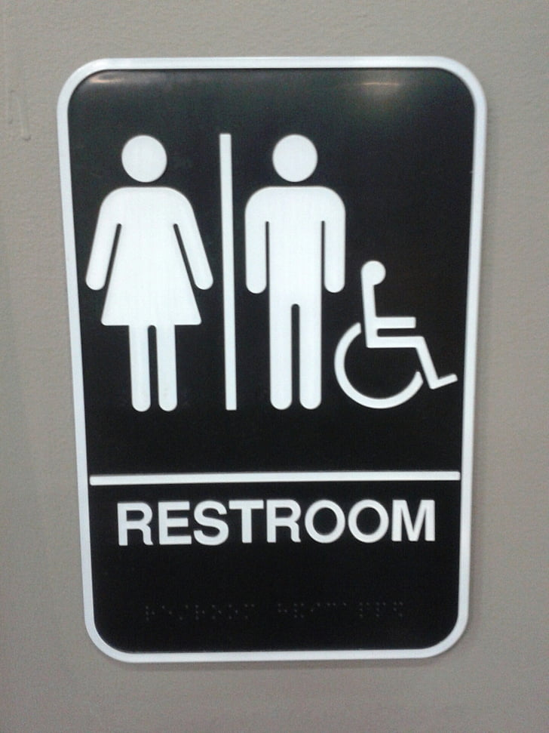
Team Tent Area
Upper Echelon Smoke
Kona Ice
Street Kitchen
Blue Scoop Ice Cream
Field
CLOSED
Field
CLOSED
Field
CLOSED
Field 1B
Field 1A

